**CAPSTONE PROJECT-WEEK 4**

**Introduction**

Yoga is becoming more popular (especially among millennials) and there is an ever-growing need and demand for holistic centers and yoga studios in metropolitan cities. Online search for yoga classes today reveals [yoga’s skyrocketing popularity](https://www.eventbrite.com/blog/academy/yoga-events-business/) among Americans — and that interest is driving a whole new generation of yogis who are willing to spend a lot of money [1]. The reference also states various other reasons into the growing popularity of yoga. The most common reasons for people to start yoga is to release the tension from their work heavy lives as well as get into a better shape physically and mentally. Keeping this in mind, a prospective business client is looking for ideal locations in the city of New York to open a chain of yoga studios.

**Approach**

The foursquare API will initially be used to identify boroughs where there is a scarcity of yoga studios to suggest locations. We will then also use the demographics data of New York City given in the link below to identify any relationships between the population and income of a neighborhood in a particular borough to the number of yoga studios present in any given neighborhood. This will give us a more detailed view of the perfect locations which the client can use. We will also look to identify any other factors such as vicinity to a particular category of venue of existing yoga studios to further refine the locations.

<https://www.kaggle.com/muonneutrino/new-york-city-census-data>

The following link is used to get the latitude and longitude data of NYC:

<https://geo.nyu.edu/catalog/nyu_2451_34572>

For example, the following pic after a k-means clustering analysis of the borough of Manhattan in New York City shows that yoga studio is one the 5 most common venues in the neighborhood of Marble Hill. This implies that this location would not be ideal for setting up a new chain of studios. Similar analysis would be performed on individual borough to identify neighborhoods where yoga studios are not that common and along with a income and population comparison, we find the ideal locations.

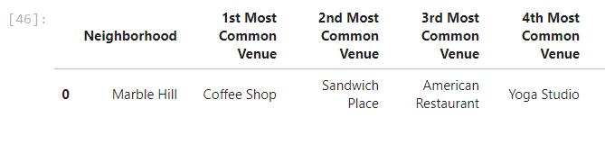

**References**

**[1]** [**https://www.eventbrite.com/blog/yoga-statistics-demographics-market-growth-trends-ds00/**](https://www.eventbrite.com/blog/yoga-statistics-demographics-market-growth-trends-ds00/)